Sprint 1 Reflection

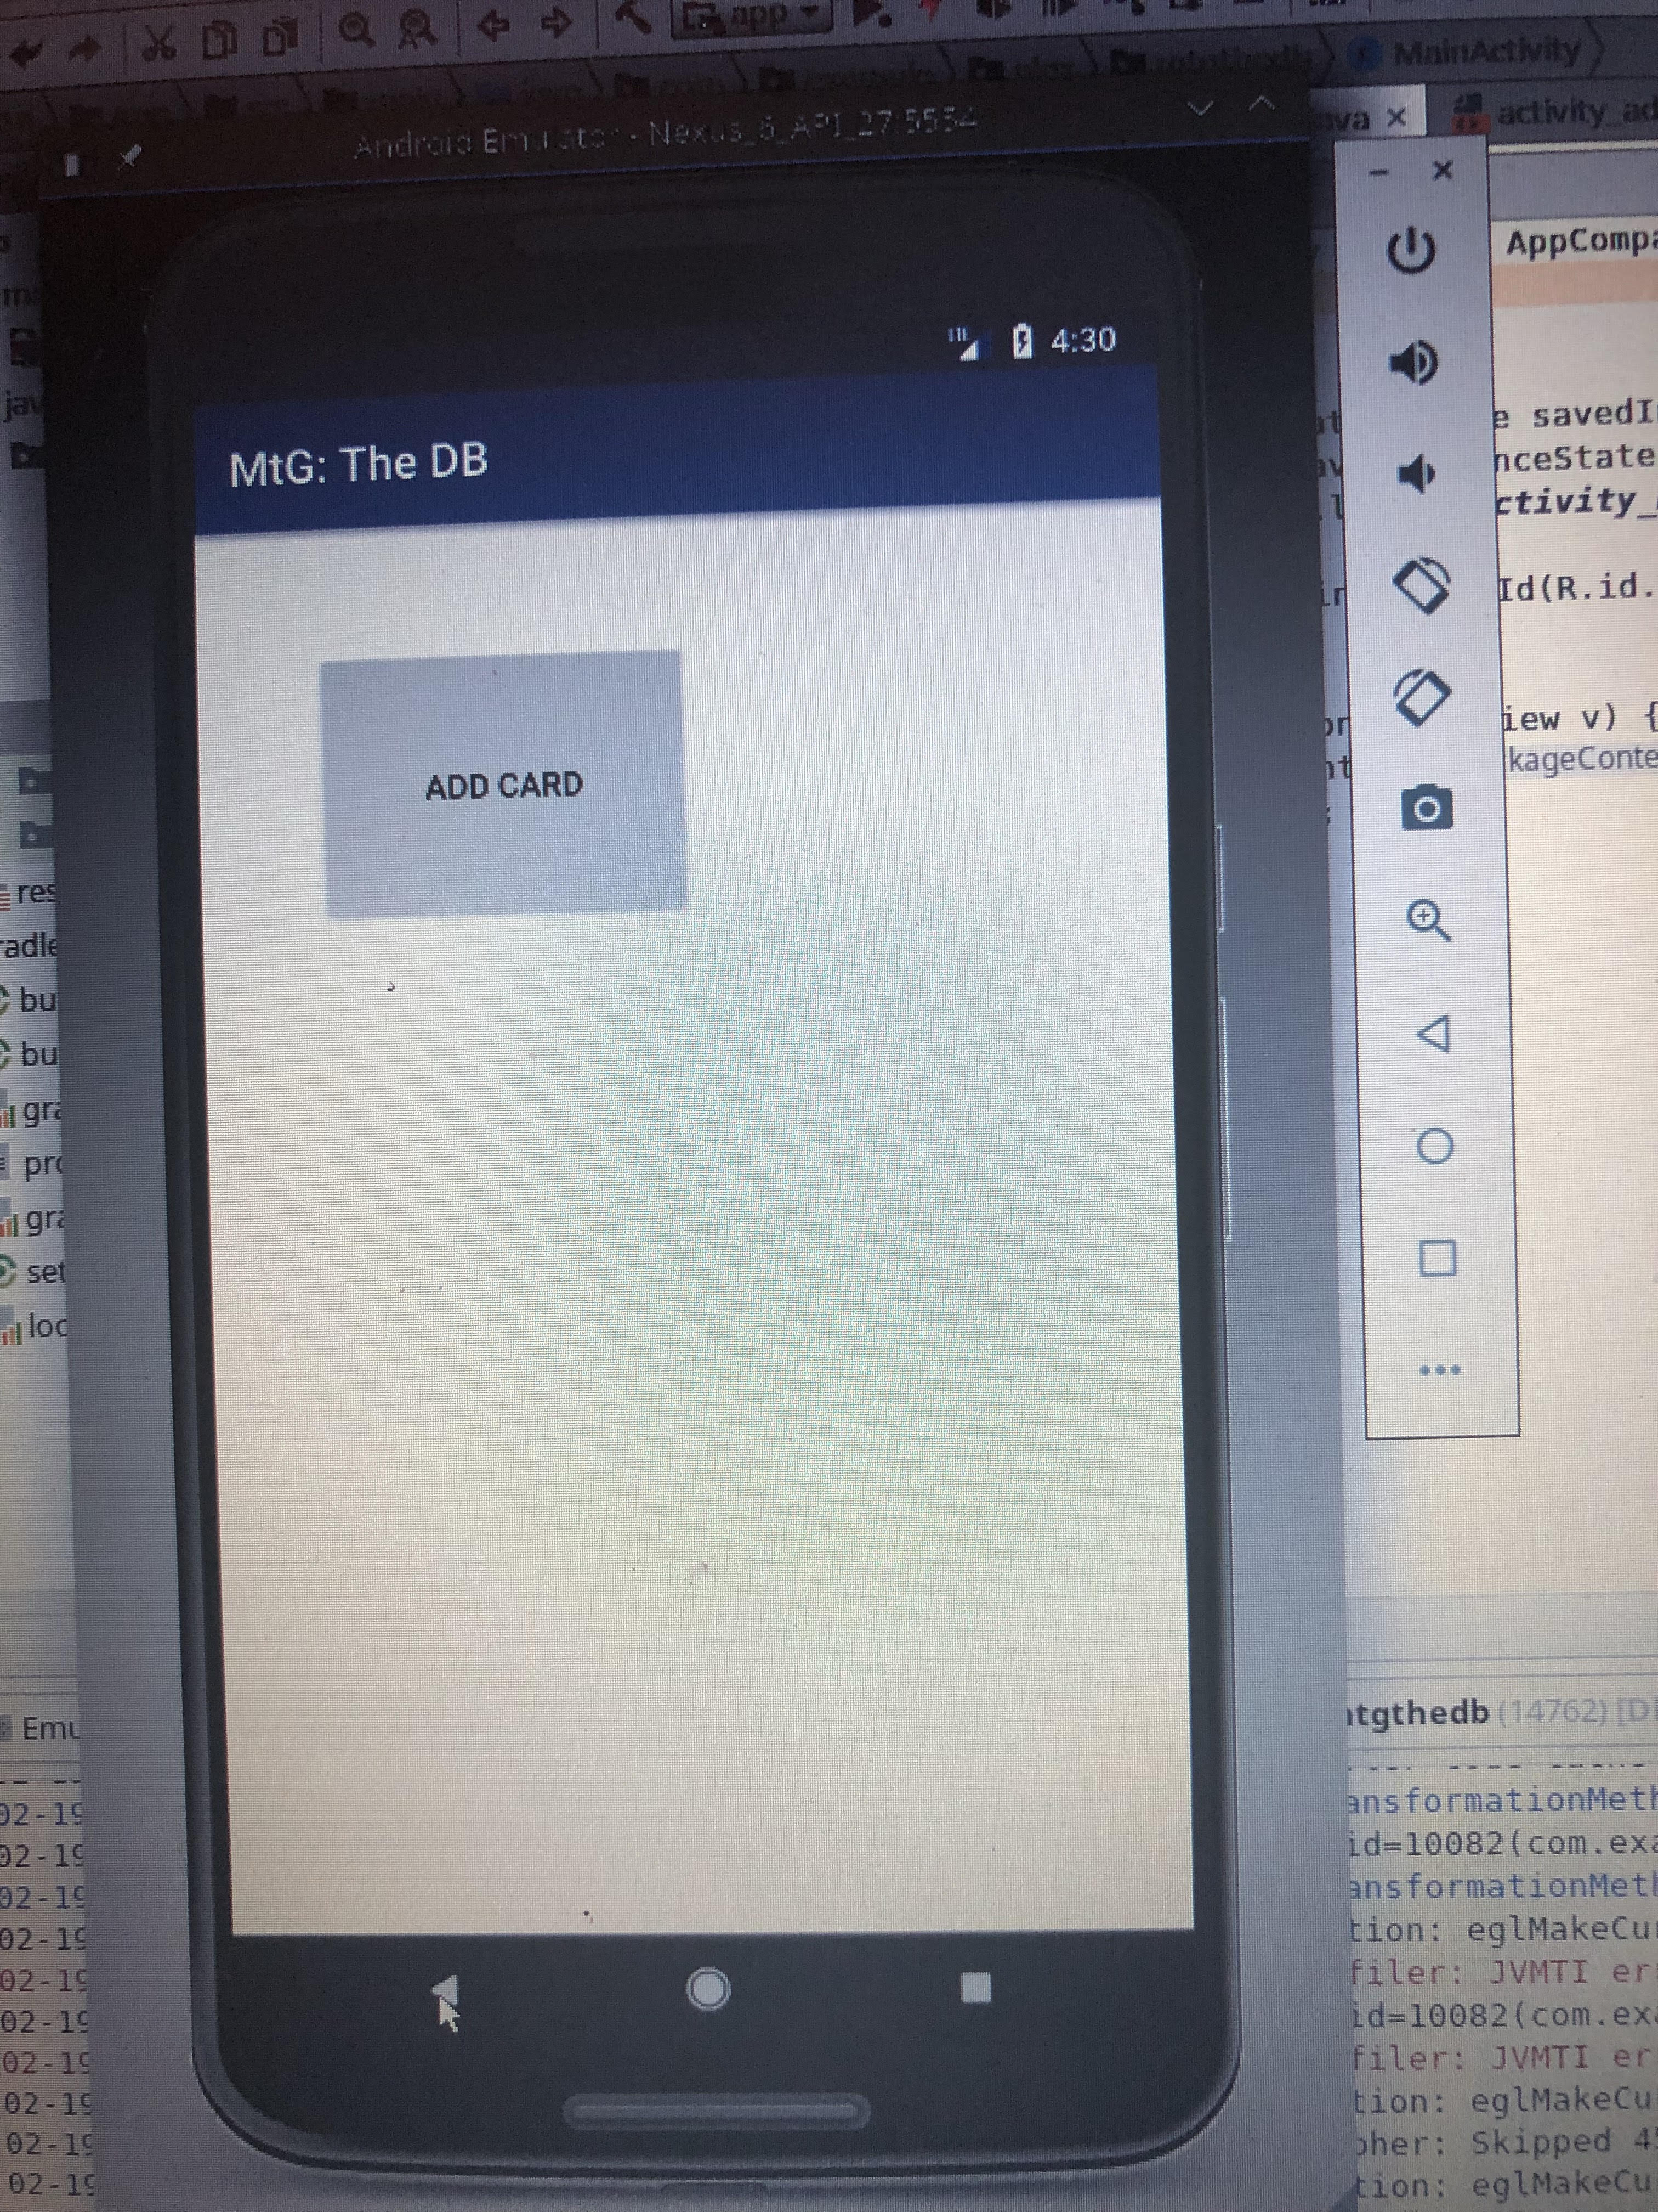**Added features:** Add Card Button to home screen

Implement Add Card Feature

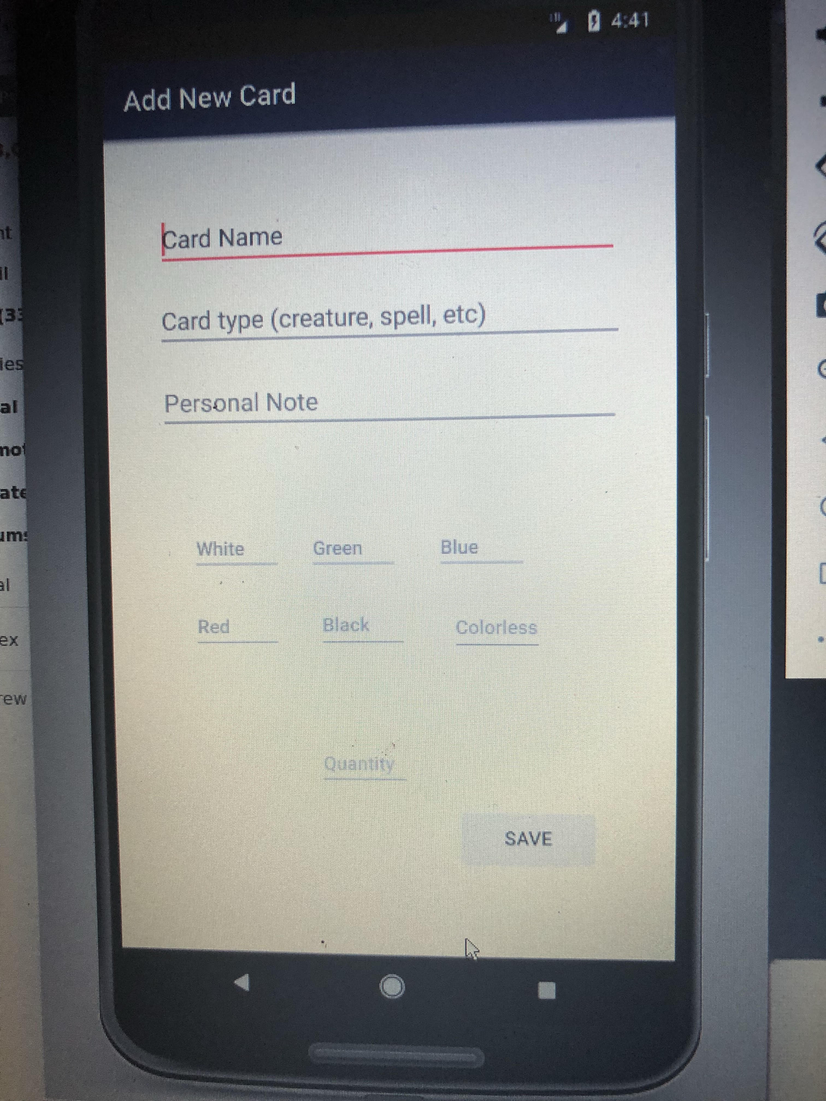

Show user input data on pushing save

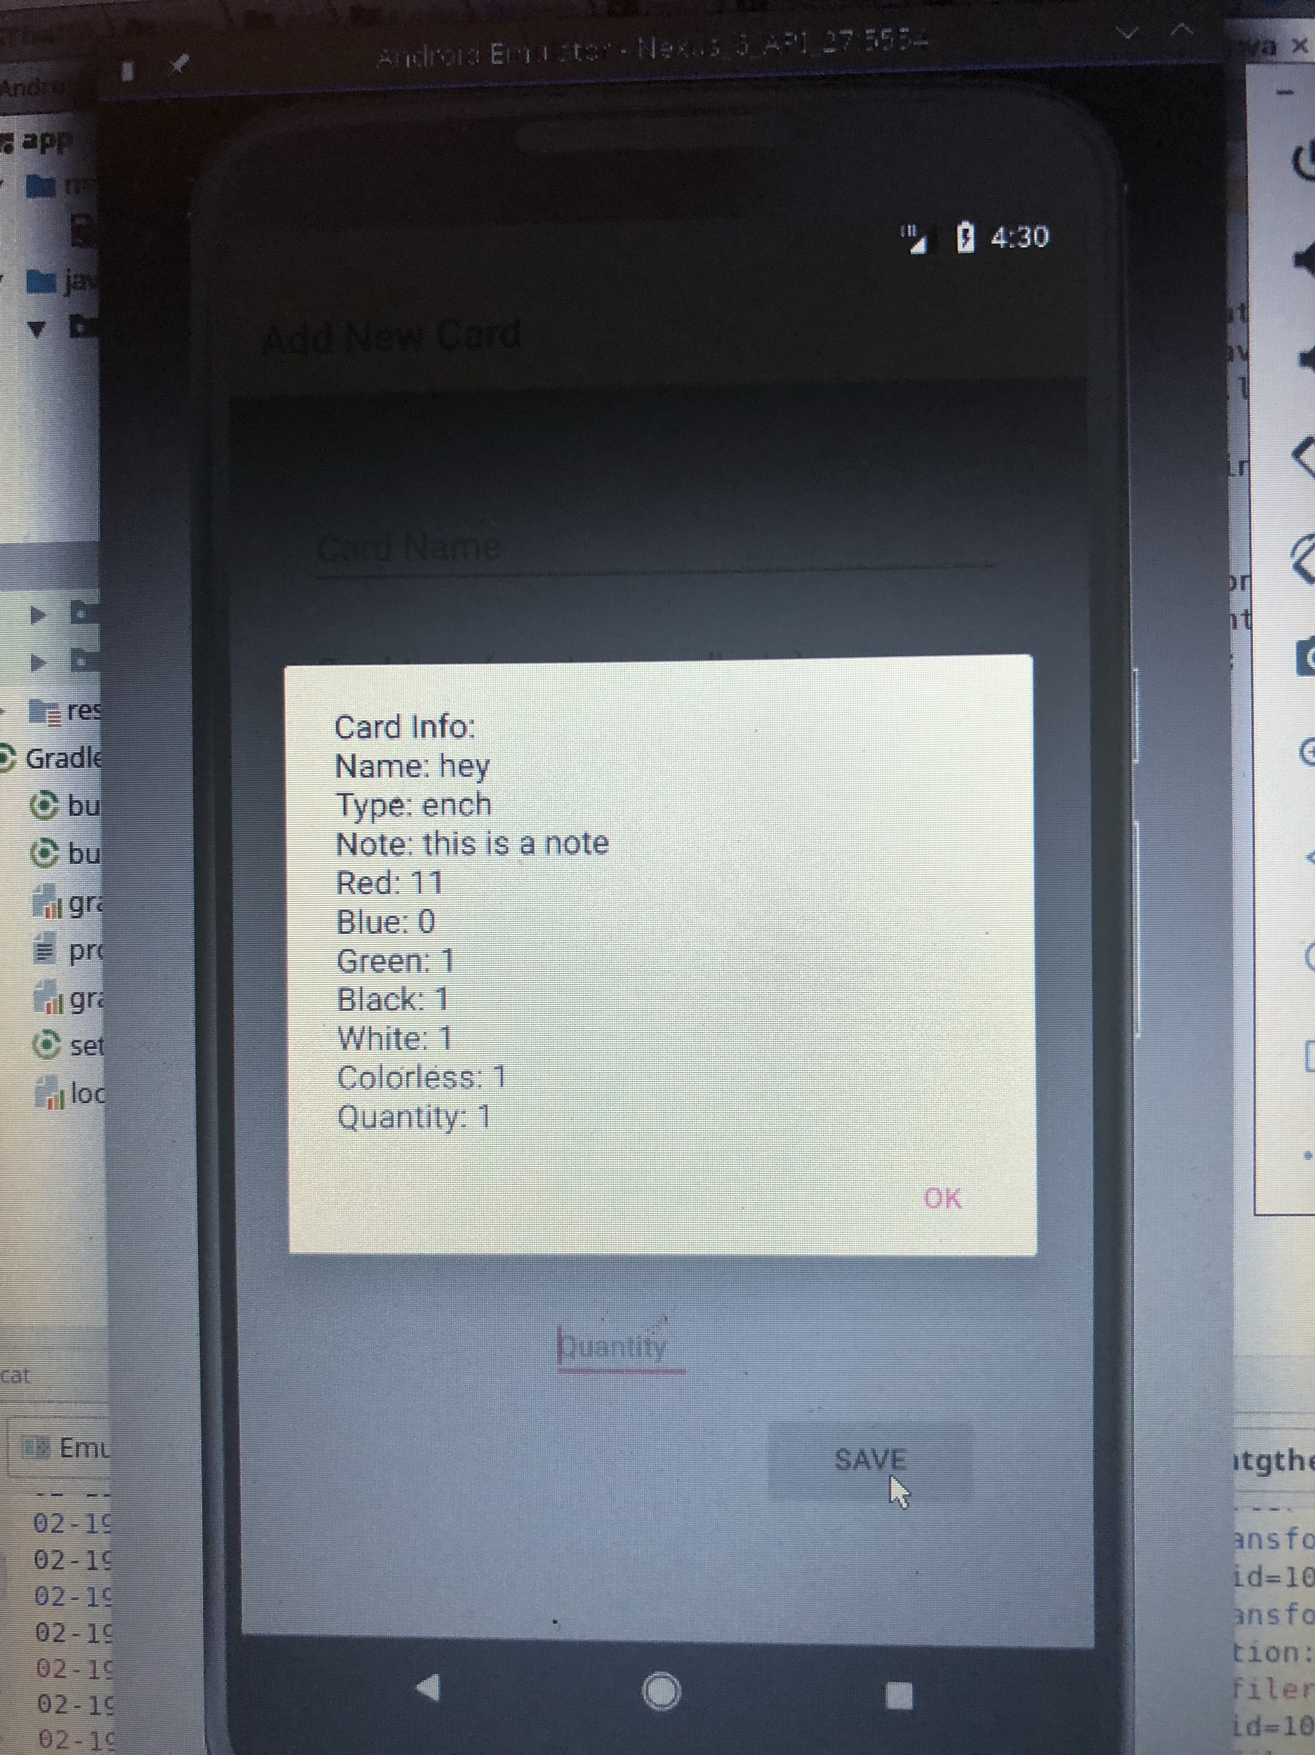

|  |  |  |  |
| --- | --- | --- | --- |
| **Story ID** | **Story / Task** | **Estimated**  **Hours** | **Actual**  **Hours** |
| S0 | Prototype full UI | 1 | 1 |
| S1 | Design the add card feature UI | 2 | 3 |
| S1 | Create actual database table(s) | 6 | 8 |
| S1 | Add relations between the tables | 3 | 0 |
| S1 | Implement all fields needed for add card feature | 5 | 3 |
| S1 | Connect DB to UI | 2 | 3 |
| S1 | Code save button  if time have system check information with user  might need to save task for later sprint | 3 | 4 |
| S1 | Design front page of app with just add button  but ensure space for all other options | 1 | 1 |
| Total |  |  | 23 |
|  |  |  |  |
|  |  |  |  |
|  |  |  |  |

Sprint review:

Currently only one table needed for functionality, so the need to create tables and add relationships was unnecessary. Otherwise, all tasks were completed. The system can add a card to the database. Currently it can be very slow and resource heavy. These issues will be addressed in next sprint.

Sprint Retrospective:

Officially, all goals were accomplished during this sprint. Every story included (that proved to be needed at this point) were included in the end of the sprint code. Comfort with XML files greatly improved between the beginning of the sprint and the end of it.

The most important improvement to make will be to research more first. Trial and error in the task of implementing a Room Database was very inefficient. Too much time was spent trying to figure out errors that could have been avoided with a bit more thorough research and planning. Moving forward I will focus more on having a full understanding of my task and my plan for executing it.

Sprint 2 Planning

|  |  |  |  |
| --- | --- | --- | --- |
| **Story ID** | **Story / Task** | **Estimated**  **Hours** | **Actual**  **Hours** |
| S1 | Improve speed of app when accessing Room | 5 |  |
| S1 | Create error message if Card lacks Name | 2 |  |
| S1 | If card already exists in DB at to the quantity | 4 |  |
| S1 | Add cancel if the user finds error in entered info | 2 |  |
| S2 | Design Search Page | 2 |  |
| S2 | Allow user to select a search by option | 4 |  |
| S1 | Use query to code delete button | 2 |  |
|  |  |  |  |
|  |  |  |  |
|  |  |  |  |